Question 1
[org 0x0100]
mov cx,0
add cx,0xDD
add cx,0xFF
add cx,0x5F
add cx,0x66
add cx,0x88
mov bl,cl
mov ax, 0x4c00 ; terminate program
int 0x21
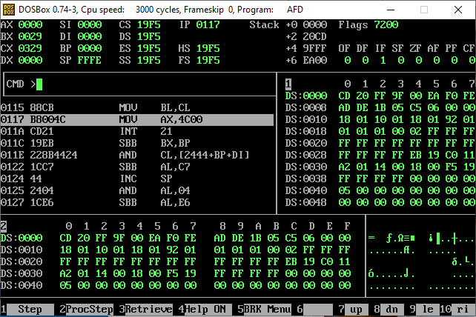
INT 0x21 is basically an interrupt call used to terminate the program.

Question 2
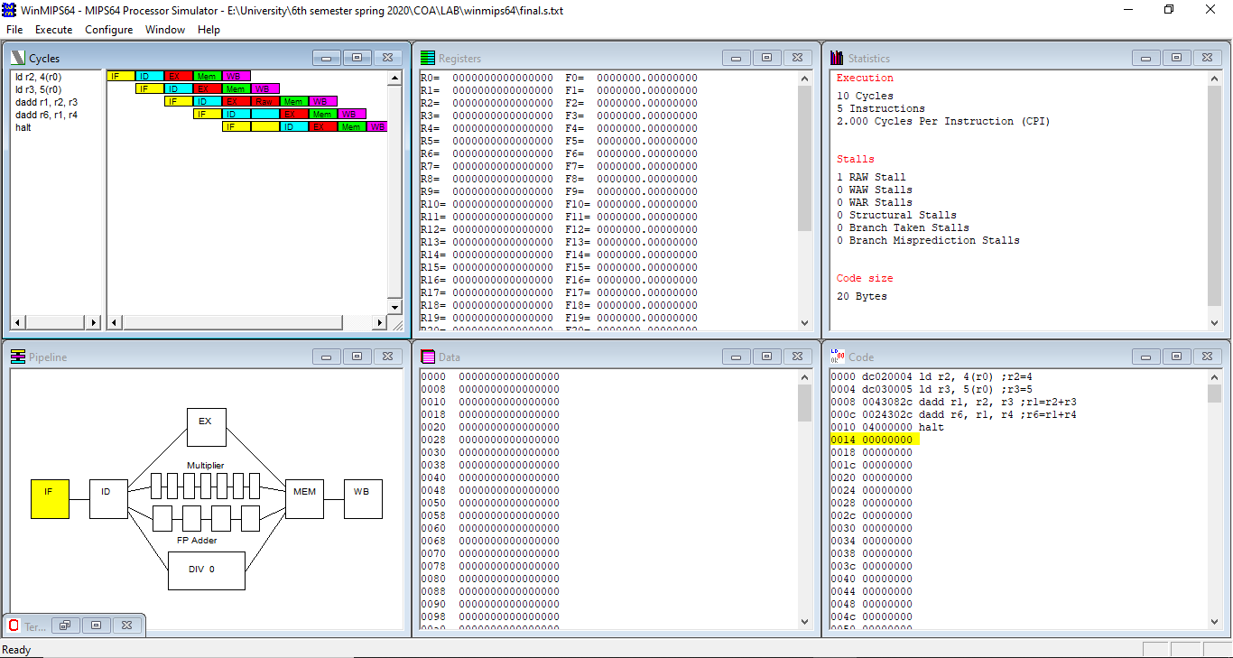

The hazard found in this pipeline is RAW hazard.
RAW hazard found which is read after write. Hazard occurs when reading is done first and then writing.

Question 3
Part A
[org 0x0100]
mov ax,0
mov SI,0
mov al,[array+SI]
inc SI
mov [0],al
mov al,[array+SI]
inc SI

mov [1h],al
mov al,[array+SI]
inc SI

mov [2h],al
mov al,[array+SI]
inc SI

mov [3h],al
mov al,[array+SI]
inc SI

mov [4h],al
mov al,[array+SI]
inc SI

mov [5h],al
mov al,[array+SI]
inc SI

mov [6h],al
mov al,[array+SI]
inc SI

mov [7h],al
mov al,[array+SI]
inc SI

mov [8h],al
mov al,[array+SI]
inc SI

mov [9h],al
mov al,[array+SI]
inc SI

mov [10h],al
mov al,[array+SI]
inc SI

mov ax, 0x4c00 ; terminate program
int 0x21
array: db 1,2,5,8,9,55,90,100,101,105,110,0
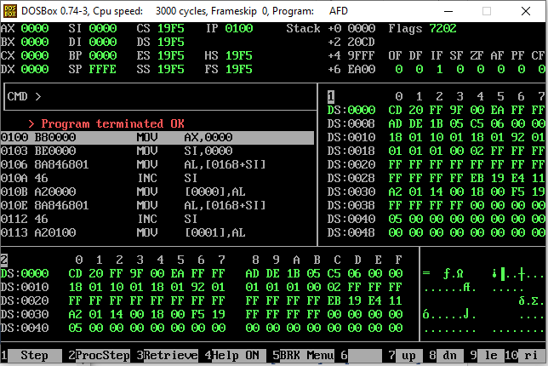
Part B
[org 0x0100]
mov cx,0x20
mov sp,0x30
mov bx,0x70
mov ax,[bx]
push ax
again:
inc bx
mov ax,[bx]
push ax
loop again

mov ax, 0x4c00 ; terminate program
int 0x21
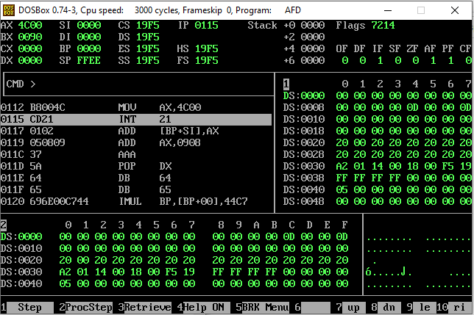
Question 4
[org 0x0100]
[org 0x0100]
mov ax,0
mov SI,0
mov al,[array+SI]
inc SI
mov [0],al
mov al,[array+SI]
inc SI

mov [1h],al
mov al,[array+SI]
inc SI

mov [2h],al
mov al,[array+SI]
inc SI

mov [3h],al
mov al,[array+SI]
inc SI

mov [4h],al
mov al,[array+SI]
inc SI

mov [5h],al
mov al,[array+SI]
inc SI

mov [6h],al
mov al,[array+SI]
inc SI

mov [7h],al
mov al,[array+SI]
inc SI

mov [8h],al
mov al,[array+SI]
inc SI

mov [9h],al
mov al,[array+SI]
inc SI

mov [10h],al
mov al,[array+SI]
inc SI

;searching 5 in the binary tree

;counting the total no of elements in the sorted array
mov DI,0
mov al,[Array+DI]
again:
inc DI
mov al,[Array+DI]
cmp al,0
jne again
mov dx,DI
;dx stores the total no of elements in the array
mov ax,DI
mov bl,2
div bl
mov cx,ax
;cx now stores the middle index of the array
;checking the midle index
mov DI,ax
mov al,[Array+DI]
mov bl,5
cmp al,bl
je equal
cmp al,bl
jg upper_class
;lower_class
mov ax,cx
mov bx,2
div bx
mov DI,ax
mov al,[Array+DI]
mov bl,5
cmp al,bl
je equal
cmp al,bl
jg upper
;lower
mov ax,DI
mov bx,2
div bx
mov DI,ax
mov al,[Array+DI]
mov bl,5
cmp al,bl
je equal
cmp al,bl
jg up
dec DI
mov ax,DI
mov bx,2
div bx
mov DI,ax
mov al,[Array+DI]
mov bl,5
cmp al,bl
je equal
mov ax,0
jmp end

up:
inc DI
mov ax,DI
mov bx,2
div bx
mov DI,ax
mov al,[Array+DI]
mov bl,5
cmp al,bl
je equal
mov ax,0
jmp end

upper_class:
sub dx,cx
mov ax,dx
mov bx,2
div bx
add ax,cx
;checking upper_class' middle index
mov DI,ax
mov al,[Array+DI]
mov bl,5
cmp al,bl
je equal
cmp al,bl
jg greater
;lesser
mov ax,DI
mov bx,cx
sub ax,bx
add ax,cx
mov DI,ax
mov al,[Array+DI]
mov bl,5
cmp al,bl
je equal
cmp al,bl
jg up
dec DI
mov ax,DI
mov bx,2
div bx
mov DI,ax
mov al,[Array+DI]
mov bl,5
cmp al,bl
je equal
mov ax,0
jmp end

greater:
mov ax,dx
mov bx,DI
sub ax,bx
add ax,DI
mov DI,ax
mov al,[Array+DI]
mov bl,5
cmp al,bl
je equal
cmp al,bl
jg up
dec DI
mov ax,DI
mov bx,2
div bx
mov DI,ax
mov al,[Array+DI]
mov bl,5
cmp al,bl
je equal
mov ax,0
jmp end

upper:
mov ax,cx
mov bx,DI
sub ax,bx
add ax,cx
mov DI,ax
mov al,[Array+DI]
mov bl,5
cmp al,bl
je equal
cmp al,bl
jg up
dec DI
mov ax,DI
mov bx,2
div bx
mov DI,ax
mov al,[Array+DI]
mov bl,5
cmp al,bl
je equal
mov ax,0
jmp end

equal:
mov ax,1

end:

mov ax, 0x4c00 ; terminate program
int 0x21
array: db 1,2,5,8,9,55,90,100,101,105,110,0

Question 5
ORG 0x100
mov SI,0
mov ah,00
mov al,03h
int 10h

MOV AH, 06h ; Scroll up function
XOR AL, AL ; Clear entire screen
XOR CX, CX ; Upper left corner CH=row, CL=column
MOV DX, 184FH ; lower right corner DH=row, DL=column
MOV BH, 11110000b ;background color = white and foreground color = black
INT 10H
again:
mov dl,[string+SI]
cmp dl,0
je terminate
inc SI
mov ah,02h
int 21h

jmp again
terminate:

MOV AX,0x4C00
INT 21H
string:db "Hello, How are you?",0
